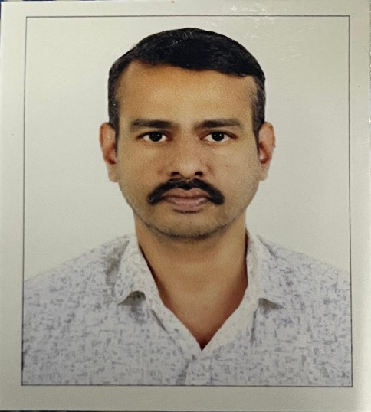

**CONTACTS**

PHONE: +91 9207591975

LOCATION: Adimali, India

EMAIL:shibukr99@gmail.com

Address: Kandamangalath (H) Panickankudy P.O idukki Kerala, India Pin:685561

# PERSONAL DETAILS

DATE OF BIRTH: 25/06/1979

MARITAL STATUS: Married

NATIONALITY: Indian

shibu k.r

**Assistant Professor – Commerce**

A highly experienced Assistant Professor with an M.Com degree and 22 years of teaching experience in the field of commerce. Proven ability to deliver comprehensive and engaging lectures, mentor students, and facilitate academic development. Adept at curriculum planning, student assessment, and fostering a positive learning environment. Committed to staying updated with current trends in commerce and education, and dedicated to guiding students towards academic and professional success.

**EDUCATION**

* **POST GRADUATION – MASTER OF COMMERCE**

MADHURAI KAMARAJ UNIVERCITY- 2017 -59%

* **POST GRADUATION – MASTER OF COMMERCE**

MG UNIVERCITY-2002-47%

* **GRADUATION- BACHELOR OF COMMERCE**

MG UNIVERCITY-2000-56%

* **PRE-DEGREE -COMMERCE**

MG UNIVERCITY-1997-58%

* **BOARD OF PUBLIC EXAMINATION, GOVT OF KERALA.**

SSLC/10th- 1995 -50%

# Work experience

# Eastern Newton School, Adimali- 2 Year

(Accounting and Statistics+1,+2)

* **Stella Marys College Adimali-12 Years**
* **Carmelgiri College, Adimali-10 Years**
* **Sophia Study Center, Adimali -15 Years**

# HOBBIES

**Reading:**  
I am passionate about reading, which has helped me cultivate a habit of continuous learning and expanding my knowledge. Through reading, I gain diverse perspectives and improve my analytical thinking, both of which are essential in my professional growth and decision-making abilities.

**Playing-Chess:**  
  
Playing chess has sharpened my strategic thinking and problem-solving skills. It enhances my ability to think critically, plan ahead, and make thoughtful decisions—qualities that contribute to my effectiveness in a professional environment.

|  |  |
| --- | --- |
| **Strength and weakness** | I, Shibu K.R. hereby declare that information provided above is true and correct to the best of my knowledge. |
| **Strength**   * Hard Working * Open minded * flexibility |  |
|  |  |

**Weakness**

* Lack of confidence
* Focusing too much on detail

# Extension activities involved/ attended/organized (provide support documents) Seminars and workshops attended

* National webinar on EWS reservation organized by Carmelgiri college, Adimali.
* National webinar on teaching during pandemic: possibilities and challenges organized by Carmelgiri province.
* Webinar on Research Methodology in commerce organized by carmelgiri college, Adimali.
* Webinar series on personal investment faculty improvement programme on 11/3/2021 organised by Dept of commerce, Carmelgiri college Adimali.
* Webinar series on how to make a research paper on 12/1/2021 organised by Dept of commerce, Carmelgiri College, Adimali

**PLACE:**

**DATE:**

**LANGUAGES**

**ENGLISH**

*Full Professional Proficiency*

**MALAYALAM**

*Native or Bilingual Proficiency*